### Cordova Plugin Installation Guide

Steps to Install the SpeedTest Plugin:

1. Unzip the Plugin:
   * Extract the contents of SpeedTest.zip to a desired location on your computer.
2. Add the Plugin to Your Cordova Project:
   * Navigate to your Cordova project directory in your terminal or command prompt.
   * Run the following command to add the plugin:

Copy code

cordova plugin add ../SpeedTest/

* + After adding the plugin, prepare your Cordova project:

cordova prepare

1. Open the Android Folder in Android Studio:
   * Locate the platforms/android directory within your Cordova project.
   * Open this directory in Android Studio.
2. Build and Run the Project:
   * In Android Studio, build your project by clicking on Build > Make Project.
   * Once the build is successful, run the project on an emulator or connected device by clicking the Run button.

Implementations:

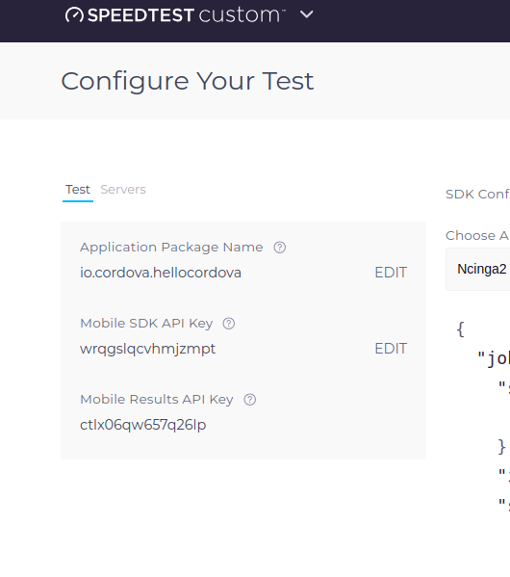Parameters

const config = {

apiKey: "key",

config: "Ncinga2",

count:2

};

api key : Ookla API key

config: Keep as default configuration

count: Test execution cycle

Add Package name to Ookla Portal:

Update your current package name on Ookla configuration

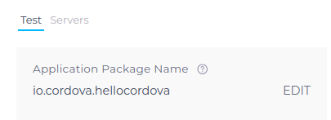

Execute Native Method:

window.cordova.exec(function (result) {

console.log(result);

}, function (error) {

console.log(error);

}, "SpeedTest", "extractJson", [JSON.stringify(config)]);

Result

ADB Log and save file

Result json files will be save on

**/data/user/0/io.cordova.hellocordova/files/SpeedTest/**

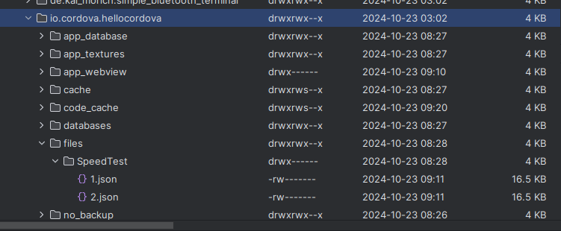

file name will be increment with loop count

ex : /data/user/0/io.cordova.hellocordova/files/SpeedTest/1.json

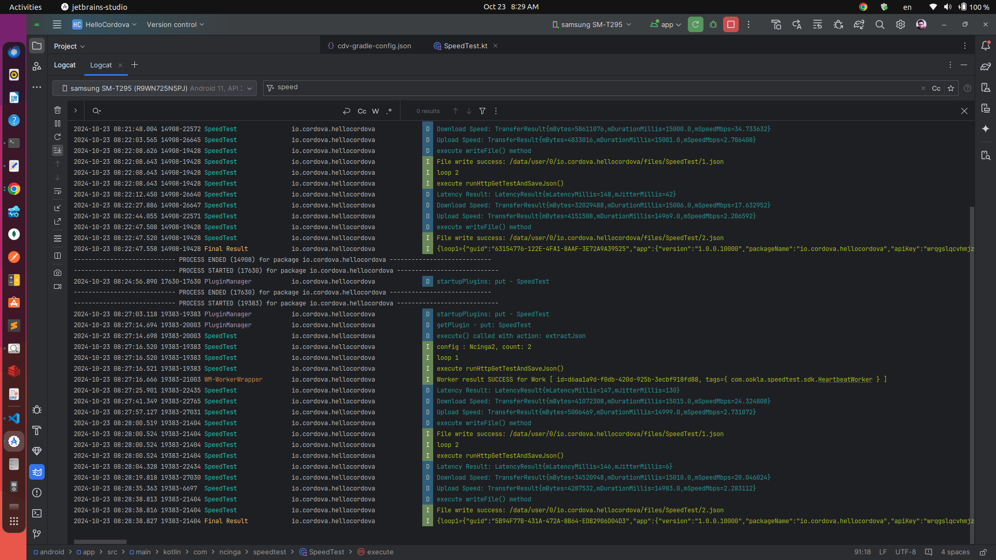

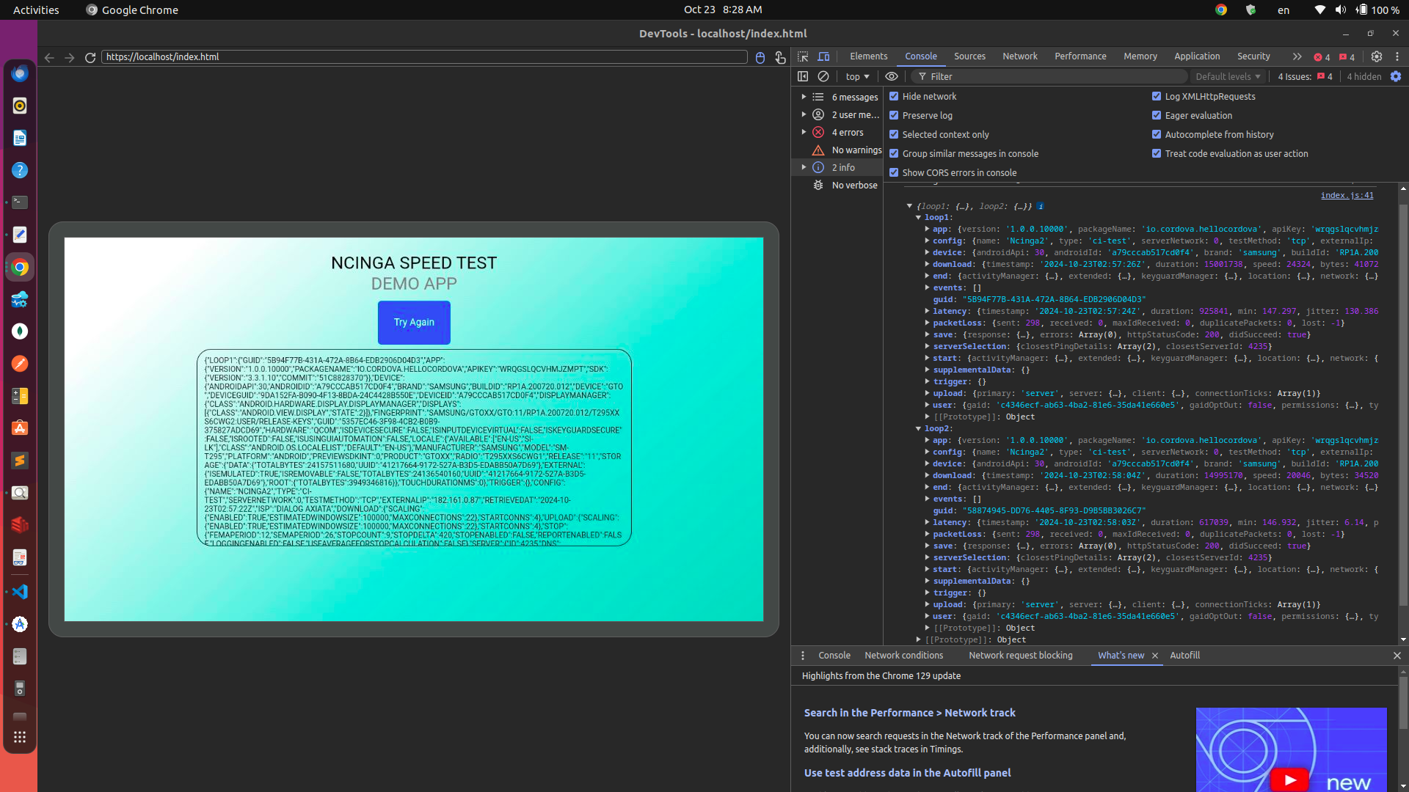Console Log Result

When success result is returning through the success callback